The Board of Education and Research
Technical Seminar
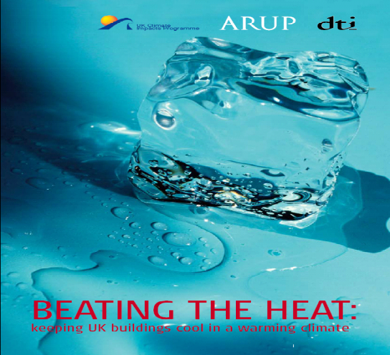

Title: Climate Change: Climate Scenarios for Urban Design:

A Case Study of the London Urban Heat Island –

Indoor Environment: Impacts and Adaptation

Date: 28 May 2007 (Monday)
Time: 6:00 - 7:30pm
Venue: HKIA Premises
19/F One Hysan Avenue Causeway Bay, Hong Kong

Free Admission and First-come-first-served

Speakers: Dr Raymond Yau, Arup HK & Dr Jake Hacker, Arup UK

Abstract

There is compelling scientific evidence that our climate is changing, and it is probable that average temperatures will increase by several degrees over the coming century. The urban heat island (UHI) makes cities more vulnerable to the effects of climate change. There is also the potential for climate change to affect the frequency and intensity of UHI events due to changes in the underlying climatology. Modelling work has been carried out through collaboration between Arup and the University of Reading in the UK to better understand the factors affecting the London urban heat island, to assist urban designers in decision making and help formulate adaptation policies to climate change. On the other hand, the increase in temperature is expected to have a major impact on the indoor environment of buildings in the UK. Key questions are:

- To what extent will climate change increase the occurrence of summertime thermal discomfort and ‘overheating’?
- To what extent will passive measures be able to improve summertime thermal comfort and ameliorate the increased propensity for overheating?
- How effective will different approaches to comfort cooling be under the changing climate?
- What are the energy use implications of the various strategies?

Biography

Dr Jake Hacker is an environmental physicist with fourteen years experience in university, government and industry research and consultancy. At Arup, his main area of work is consultancy on climate change issues for urban planning and building design. He has led a number of projects in this area in recent years. He is also currently leading Arup’s strategic thinking on climate change and over the last two years has led the Arup Drivers of Change project on climate change, aiming to gather the key facts about climate change and communicate these to internal and external audiences. Jake has been lead author of a number of major reports and papers on climate change impacts and adaptation, e.g., Climate Change and the Internal Environments of Buildings, London’s Urban Heat Island Research, UK Climate Impacts Programme Briefing Report, and speaks regularly on this subject at internal and external meetings.

Dr Raymond Yau is Director of Arup Hong Kong and Member of Global Buildings Sector Board of Arup Group. He is a building services engineer and building physicist with twenty years work experience in integrated design of sustainable and environmental responsive buildings and in sustainability planning and consulting. He is a world leading CFD specialist on built environment applications. He is Head of Building Physics and Sustainability Group in Arup’s East Asia Region. He involved in many pivotal sustainable consulting studies for the HKSAR Government, which have had a strong influence on the development of sustainability in Hong Kong. Those projects include Microclimate Research of Public Housing, CEPAS and LCEA. Raymond’s sustainable design and consulting expertise in Hong Kong and Mainland China has been recognised with local and international Sustainability Awards. He led the zero carbon energy strategy of the World’s First Eco-City project in Shanghai Dongtan, Mainland China.

Registration & Enquiry

Please complete & return the attached Registration Form by 25 May 2006 to Fax: 2882 8402. For enquiry, please contact Ms Karen CHOW at Tel: 2890 6373 or email: karen.chow@hkie.org.hk.

_____________________________________________________________________________________

Climate Change: Climate Scenarios for Urban Design

Registration Form

Name: |  |  |  |  |  |  |  | Title:
Telephone No:
Fax No:
Email Address:
Membership |  | HKIA |  | HKIE |  | HKILA |  | HKIP |  |  | HKIS
 |  | Others:
Membership No:

